# **Applied Data Science and Analysis on Financial Data**

## ****Growth Rate****

### **Straight line**

### **Moving average**

### **Simple linear regression**

### **Multiple linear regression**

## Profitability Analysis

### **Profitability is a type of income statement analysis where an analyst assesses how attractive the economics of a business are. Common examples of profitability measures include:**

### **Gross margin**

### **EBITDA margin**

### **EBIT margin**

### **Net profit margin**

## ****Liquidity Analysis****

**This is a type of financial analysis that focuses on the balance sheet, particularly, a company’s ability to meet short-term obligations (that due in less than a year). Common examples of liquidity analysis include:**

### **Current ratio**

### **Acid test**

### **Cash ratio**

### **Networking capital**

## **Financial monitoring**

A system to detect a large number of micropayments and flag such money laundering techniques as smurfing.

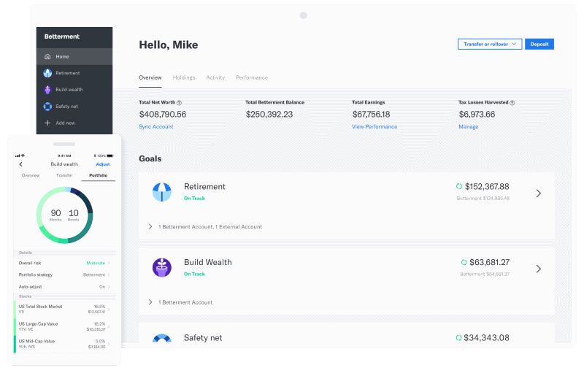

## Sentiment/News Analysis

Social media, news trends, and other data sources, not just stock prices and trades.

The stock market moves in response to myriad human-related factors that have nothing to do with ticker symbols, and the hope is that machine learning will be able to replicate and enhance human “intuition” of financial activity by discovering new trends and telling signals. Textual data can then be provided to machine learning models in the form of vectorized text or vector embeddings, removing the need for humans to trawl through financial news and reports manually. Market sentiments play a crucial role in financial markets and stocks and may be contained in:

* News reports.
* Blogs.
* Quarterly company reviews.
* Financial Statements.
* Social Media platforms such as [Twitter](https://twitter.com/), [YouTube](https://youtube.com/), or [TikTok](https://www.tiktok.com/en/" \t "_blank).

Formerly, it’d be the trader’s job to manually track market sentiments and adjust trading strategies accordingly. ML can assist in extracting sentiment from textual data via natural language processing.

## Making Investment Predictions

Identify specific market changes much earlier as compared to the traditional investment models.

With renowned firms such as Bank of America, JPMorgan, and Morgan Stanley investing heavily in ML technologies to develop automated investment advisors, the disruption in the investment banking industry is quite evident.

## Financial Advisory

There are various budget management apps powered by machine learning, which can offer customers the benefit of highly specialized and targeted financial advice and guidance. Machine Learning algorithms not only allow customers to track their spending daily using these apps but also help them analyze this data to identify their spending patterns, followed by identifying the areas where they can save.

## Customer Sentiment Analysis

Machine learning models can be of great help to finance companies when it comes to analyzing current market trends, predicting the changes, and social media usage for every customer.

Because human factors primarily drive the stock market, businesses need to learn from the financial activity of users continuously. Further, consumer sentiment analysis can also complement current information on different types of commercial and economic developments.

What are the levels of cashflows/debts/assets compare to others through time and analyze the impact in the next years?

For example, some company might have low cashflows compare to others in the same industry but it is because they are investing it in R&D

So even though, they are in a riskier place now they can be better in the next few months

If you are not very familiar with all this financial information a will understand what does each of them means and how they are related.

## Efficiency Analysis

Efficiency ratios are an essential part of any robust financial analysis. These ratios look at how well a company manages its assets and uses them to generate revenue and cash flow.

Common efficiency ratios include:

### [Asset turnover ratio](https://corporatefinanceinstitute.com/resources/knowledge/finance/asset-turnover-ratio/)

### [Fixed asset turnover ratio](https://corporatefinanceinstitute.com/resources/knowledge/finance/fixed-asset-turnover/)

### [Cash conversion ratio](https://corporatefinanceinstitute.com/resources/knowledge/finance/cash-conversion-ratio/)

### [Inventory turnover ratio](https://corporatefinanceinstitute.com/resources/knowledge/finance/inventory-turnover-ratio/)

# **Cash Flow**

### [Operating Cash Flow (OCF)](https://corporatefinanceinstitute.com/resources/knowledge/accounting/operating-cash-flow/)

### [Free Cash Flow (FCF)](https://corporatefinanceinstitute.com/resources/knowledge/valuation/what-is-free-cash-flow-fcf/)

### [Free Cash Flow to the Firm (FCFF)](https://corporatefinanceinstitute.com/resources/knowledge/modeling/free-cash-flow-to-firm-fcff/)

### [Free Cash Flow to Equity (FCFE)](https://corporatefinanceinstitute.com/resources/knowledge/valuation/free-cash-flow-to-equity-fcfe/)

# **Rates of Return**

### At the end of the day, investors, lenders, and finance professionals, in general, are focused on what type of risk-adjusted rate of return they can earn on their money. As such, assessing rates of return on investment (ROI) is critical in the industry.

### Common examples of rates of return measures include:

### Return on Equity (ROE)

### Return on Assets (ROA)

### Return on invested capital (ROIC)

### Dividend Yield

### Capital Gain

### Accounting rate of return (ARR)

### Internal Rate of Return (IRR)

### Valuation Analysis

### Scenario & Sensitivity Analysis

### Variance Analysis

# **What else do we need:**

# **What value is more important:**

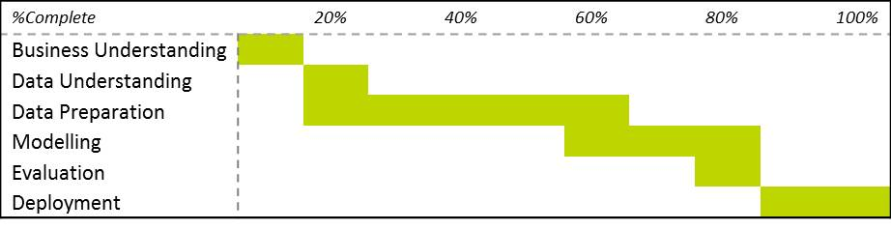

# **Data Structure**

# **References:**

<https://www.datacamp.com/courses/financial-forecasting-in-python>

<https://datafloq.com/read/machine-learning-can-assist-with-five-year-balance/7588>

<https://www.tableau.com/about/blog/2018/6/how-analytics-helps-cash-flow-management-uncovering-key-details-89269>

<https://medium.com/@kcherniwchan/a-fully-automated-approach-to-cash-flow-forecasting-29b3b0ef71f3>

<https://spd.group/machine-learning/ml-in-finance/>

<https://www.edx.org/professional-certificate/nyux-machine-learning-and-finance>

<https://understandingdata.com/machine-learning-in-the-finance-industry/>

<https://corporatefinanceinstitute.com/resources/knowledge/finance/types-of-financial-analysis/>

<https://www.turing.ac.uk/research/research-programmes/finance-and-economics/machine-learning-finance>

<https://arxiv.org/pdf/1506.00327v1.pdf>

<https://github.com/keon/deepstock>

<https://www.oldschoolvalue.com/financials-accounting/balance-sheet-ratios/>